Dunwoody High School

AP Macroeconomics

Summer Assignments – 2024-2025
Macro Teachers:
Mr. Chriszt Jonathon_chriszt@dekalbschoolsga.org
Mrs. Lampron laura_lampron@dekalbschoolsga.org

Materials Needed on Day 1
- Hard Copy - CEE AP Macroeconomics Student Workbook, 5th Edition (It is light blue and costs $29.95) Order early!

https://store.councilforeconed.org/shopping_product_detail.asp?pid=52426

PRO TIPS: DO NOT BUY THE EBOOK. DO NOT ACCIDENTALLY BUY THE TEACHER’S MANUAL. DO NOT BUY IT ELSEWHERE, SUCH AS AMAZON. TRUST US ON THIS! If you have financial need, please contact one of the AP Macro Teachers.

- 4 Function Basic Calculator. If it costs more than $5, it is too fancy! The College Board has strict rules regarding calculators.
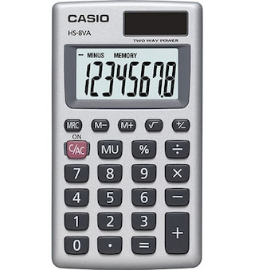
- Composition book for warm-up assignment.
- 3 ring notebook with 6 dividers (recommended to stay organized)
- Pencil, pen, paper
- Ruler (optional)
- Graph paper (optional)

Summer Reading: Optional but strongly encouraged!

Incentive to do the reading and assignment: Satisfactory completion of the summer work any time prior to the last day of Thanksgiving Break will earn the student up to a 100% replacement grade for their lowest test grade. However, the students may not take a zero on a test and replace it with a 100%.

Obtain and Read Naked Economics by Charles Wheelen
- A used copy is fine!
- A new copy is fine!
- A library copy is fine!
- Listening to it on Audible or another platform is fine!
- An old edition is fine!

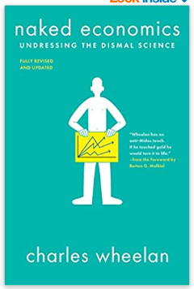

Complete this GoogleForm while you are reading the book. https://forms.gle/baig4DDHPQBu64WH9

 | Unsatisfactory  0-3 | Below Expectations  4-6 | Meets Expectations  7 or 8 | Exceeds Expectations  9 or 10 | Multi-  plier | Your Score
Proper Length | ALL definitions and examples are too short or too long. | Most definitions and examples are too short or too long. | Some definitions and examples are too short or too long. | ALL terms are defined in 1 -2 sentences, ALL example are explained in 3-5 sentences. | 2
Terms & definitions | Copied directly from another source. | Copied some definitions word-for-word from the book, the internet, or another source OR incorrectly defined many terms. | Attempted to use one’s own words to define the selected terms but made some minor errors. Copied word-for-word from the book/internet for a few terms. | Chose a good term to work with and used one’s own words to define it. All definitions were correct. | 3
Examples | Examples were copied directly from another source and/or some of the “original” examples were nearly identical to those seen in another student’s work. | All examples came from another source (rather than one’s own head) but were “reworked”. | Some examples are original and others were obtained through an internet search but then reworked to avoid plagiarism. | All examples are original and are correct for the selected terms. | 5

Total Score: _____/100

